**Finishing Strong**

**Participant Guide**

*LALLEMAND ANIMAL NUTRITION*

www.lallemandanimalnutrition.com

Day 1: Managing Objections and Closing the Sale 4

Welcome and Introduction 4

Sales Excellence Program Review 4

Agenda 5

Icebreaker 5

Review: The STEP Process 6

Module 1: Handling Objections 7

Common Objections 7

Activity: Common Objections 8

Activity: The Price Objection 9

Activity Debrief 10

The Objection Management Process 11

Activity: Question Simulation 12

Your Commitment 13

Module 2: Closing the Sale 14

What Does It Mean to Close? 14

The ABCs of Closing 15

Gaining Customer Commitment 16

Activity: Gaining Commitment 18

Closing Techniques 19

Activity: Closing Techniques 21

Trial Close 24

Day 2: Buying Signals and Follow-Up 25

Module 3: Interpreting Buying Signals 25

Buying Signals 25

Verbal Buying Signals 26

Nonverbal Buying Signals 27

Challenges of Nonverbal Communication 28

Activity: Identifying Nonverbal Signals 29

Interpreting Verbal & Nonverbal Signals 30

Closing Scenarios 31

Activity: Determining When and How to Close 32

Module 4: Following Up After the Sale 35

Purpose of Post-call Follow-up 35

Selling as a Cycle 36

Stage One: Ensure Positive Experiences 37

Stage Two: Building the Relationship 38

Stage Three: Expanding the Partnership 39

Activity: Creating a Follow-up Plan 40

# Day 1: Managing Objections and Closing the Sale

### Welcome and Introduction

#### Sales Excellence Program Review

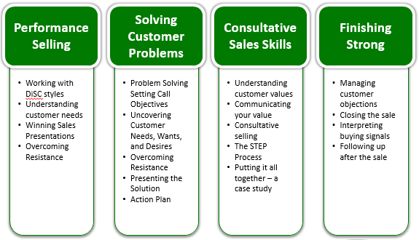

#### Agenda

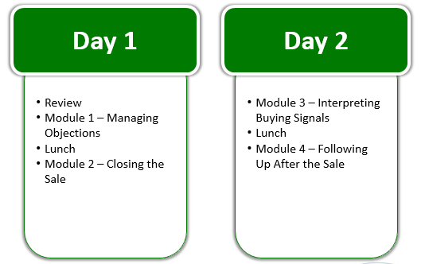

#### Icebreaker

During the past three sessions, you learned about call planning, customer needs, presenting the solution, and consultative selling skills. What practices have you taken from last year that have most impacted your work?

This course will build on and reinforce what you’ve learned thus far.

#### Review: The STEP Process

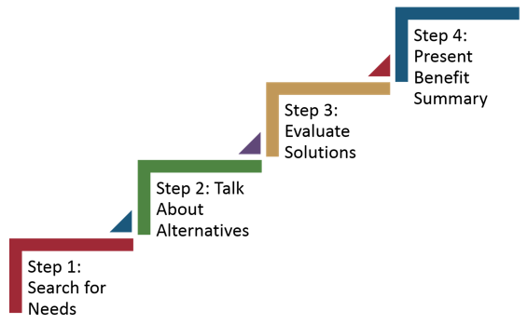

**Notes:**

### Module 1: Handling Objections

In theory, your preparation will uncover the most critical needs of your customers, as well as any issues or negative feelings concerning your product or your business. In reality, good preparation may allow you to anticipate most objections before they happen — but no amount of preparation guarantees you’ll hear no objections. Sometimes, early in a call, you find customers simply aren’t interested. When this happens, don’t take it personally — just thank them for their time, leave the door open for future business, and exit gracefully.

When you hear a detailed, specific objection as you prepare to close the call, then the objection likely has a very different meaning. Why? As you discuss your products and services with customers, you are able to focus more and more tightly on their needs. They, in turn, also begin to “try on” the idea of doing business with you. Until the customer is seriously considering how a business relationship with you would work, you may not hear serious objections — he/she does not care enough to object.

#### Common Objections

1. **What are the common objections you hear from customers today?**
2. **What objections are the most difficult for you to handle?**

#### Activity: Common Objections

**Instructions:** Work in your small group to develop a response for the objection(s) the facilitator assigned to you.

|  |  |
| --- | --- |
| Objection | Potential Response |
|  |  |
|  |  |
|  |  |
|  |  |
|  |  |

#### Activity: The Price Objection

**Scenario:** You visit a customer and find that your competitor was there yesterday. Their price is $0.10 cheaper per treated ton. The customer wants to know why he should pay more for a Lallemand product.

**Develop a simple set of talking points for how you would respond to this customer’s objection.**

**Develop a list of questions to consider in order to isolate the customer’s real issue or concern.**

#### Activity Debrief

**What key responses came up in your group discussion?**

**At what point did you struggle, or have difficulty, formulating responses for the producer?**

**How do your proposed responses address the producer’s concern?**

**What did we learn from this activity that will help us manage and resolve objections more effectively?**

#### The Objection Management Process

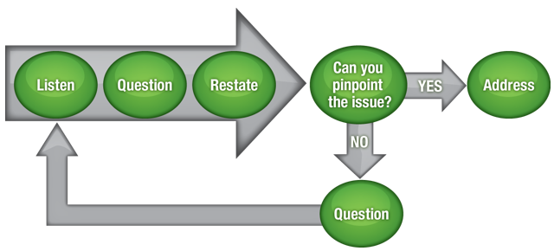

**Step 1: Listen**

* The first step in the managing objections process is to listen to the customer.
* Listening to the customer shows that you are concerned with his/her needs and gives you an opportunity to empathize with him/her.

**Step 2: Question**

* The next step in the process is to ask questions.
* A customer will not always clearly state his/her concern. Asking questions will help you to isolate the customer’s real concern.

**Step 3: Restate**

* Before you pinpoint or address the concern, it is critical to restate the concern to the customer so that you’re sure you’re understanding the concern correctly.
* Restating the objection in your own words will help to confirm the real concern.
* The idea here is that you let customers know you understand their concerns so they know you’re listening *and* so that you know how to address the concerns.
* Customers are opening up to you and trusting you with their thoughts and opinions. Don’t just jump into explaining why their objections or concerns are wrong.

**Step 4: Pinpoint and Address**

* The final step is to pinpoint and address the customer’s concern.
* If the customer responds with a “No” to your restatement of his/her concern, you must go back and review your understanding of the customer’s situation. This requires you to ask additional questions to uncover his/her real concerns and needs.
* If the customer responds with a ”Yes”, then you are ready to address the objection.
* Depending on the objection, how you will address the objection will depend on the situation.

#### Activity: Question Simulation

**Instructions:** Choose a partner near you for this activity. One of you will play the role of the seller asking questions, and the other will play the role of the buyer.

* If you are playing the buyer, choose an objection from our list and begin expressing your concern.
* If you are playing the seller, listen to the buyer and ask your questions in order to uncover the concern.
* Stop the role-play after one minute and determine if the questions being asked by the seller are appropriate to bring out the real concern or if you should redesign the questions.
* Then, restart the role-play and practice with the new questions.

**Notes:**

#### Your Commitment

In order to have the content that was covered today become part of your behavior and routine on the job, we would like to challenge you to make specific commitments by completing each section in this worksheet. In order to ensure accountability with these commitments, this worksheet will be left with your supervisor, so he/she can follow-up on your progress.

**Identify one thing you will stop doing immediately:**

**Identify one thing you will start doing immediately:**

**Write one commitment that you will apply to improve your effectiveness:**

### Module 2: Closing the Sale

#### What Does It Mean to Close?

Closing does not just happen at the end of the sale, but it is a culmination of your efforts throughout the sale. There are three situations that you need to close.

1. The first is when you open a call or establish a relationship. Each time you interact, your first “close” is to convince customers that it’s worth their time to listen to you.
2. The second is when you offer the expertise, insights, products, programs, and services you believe best fit the customer’s unique operation. You are selling the desirability, or fit, of your solutions.
3. Lastly, when you close the discussion by asking for the next opportunity to add value, a long-term partnership, or possibly the sale, you are selling the customer on making a decision to commit.

**Notes:**

#### The ABCs of Closing

Asking questions is an important way to navigate the different steps involved in the closing process. Great salespeople do not just ask for a customer’s business once, nor do they ask for the sale in the same manner. For example:

* **Ask #1 -** Do you have a moment to talk about ways we might improve your profitability?
* **Ask #2 -** Could you see value in achieving adequate pesticide spray coverage throughout the crop canopy?
* **Ask #3 -** Could I have your business?

How often do you need to ask for the business?

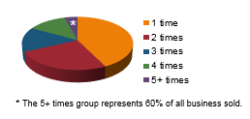

*Consider this:* Sixty percent of all business sold is by individuals who ask five or more times.

How many times do you ask customers for their business? The key to success is to always be closing.

**Notes:**

#### Gaining Customer Commitment

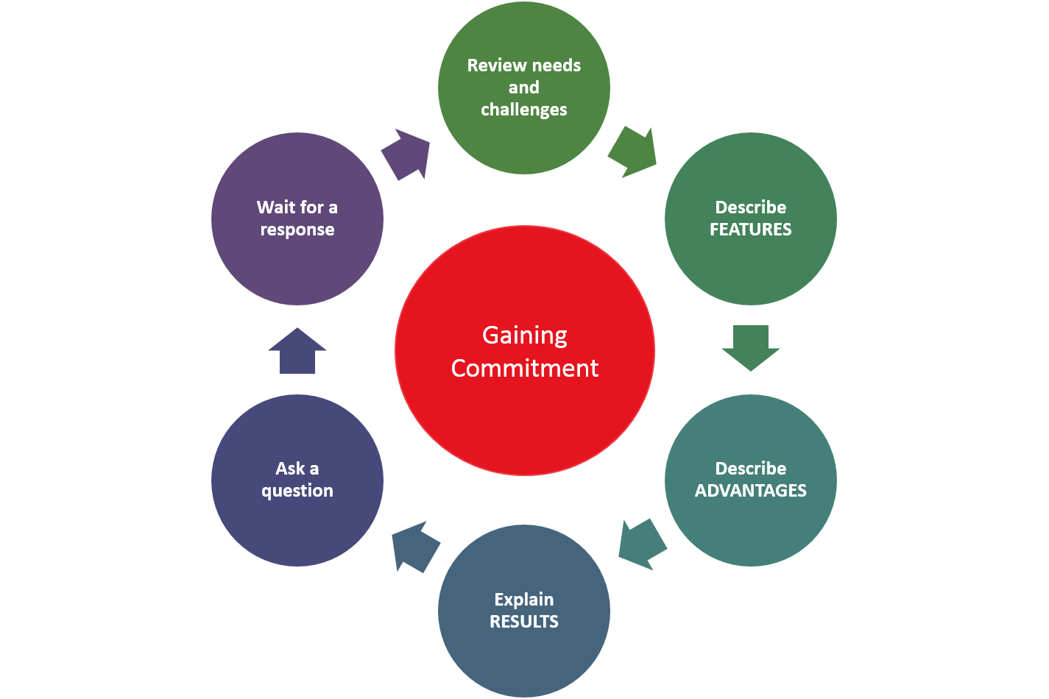

Use this six step process to gain customer commitment:

1. Review the customer’s needs and challenges.
   * Review the prior agreed upon needs and problems.
   * Example: You can begin by using a phrase such as, “Earlier you stated that you are interested in improving the quality of your silage…”
2. Describe the solution, starting with the features.
   * This is the point where you start making recommendations.
3. Describe the advantages of the solution.
   * Communicate the advantage to the customer by describing what the product is, what it does, and what’s in it for the customer.
4. Explain how each feature will solve a challenge, creating a desired result.
   * You will gain a competitive advantage by using this step of the process to emphasize the results that are of the most value to the customer’s unique situation and needs.
5. Ask a reaction question to gain agreement.
   * How do you see this product working for your business?
   * In what ways would this product be helpful to you?
6. Wait for a response.
   * When you are silent, the customer has time to collect his/her thoughts while processing the information that you’ve presented. Silence can be a respectful way of listening and helping the customer focus on how the product can work in his/her situation.
   * You are in control of the silence in the conversation. Think of it almost like a game – the first one to speak loses. This may be uncomfortable for you, and you may start to feel impatient. Don’t give in! Trust that the customer has something to say… and just needs time to figure out how to say it.
   * There are many instances in which, rather than gaining commitment, the customer will push back. This is your opportunity to ask clarifying questions to get back to the heart of the discussion. Then repeat the process for gaining the customer’s commitment.
   * Not waiting for the customer to speak can have negative consequences. You may be so uncomfortable or impatient when waiting for that answer that you try to counter an objection that the customer hasn’t actually brought up, especially if it’s one you’ve had trouble with before.
     + **Example:** Bob’s nearing the end of a sales call and his customer, Jim, seems to be on the fence about whether or not to buy. Bob has gone through the steps to gain commitment, and he asked Jim how he sees the product working in his business. Jim leans back in his chair, crosses an arm over his chest, and taps his chin with one finger. He’s quiet for what seems like an eternity, but it’s really been less than a minute. Bob thinks of a frequent, frustrating objection he gets for this product: price. Before Jim says anything, Bob asks “What’s holding you back right now? Is it the price?”
   * The customer could have been thinking about any number of things at that moment, and if he wasn’t thinking about the price then Bob just put it in his mind. Now Jim will likely wonder if Bob’s other customers frequently complain about the price. He may wonder if the product is priced too high, even though he hadn’t thought that before.
   * This example highlights behavior with sales reps who haven’t participated in training like the one you’re in right now. If you follow the full six steps for gaining commitment, you’ll have the key to success when there’s silence!

#### Activity: Gaining Commitment

Instructions: Listen to the role-play between a Lallemand sales rep and a customer. In your group, brainstorm to determine which Lallemand products best meet the customer’s needs based on what you’ve heard. Work through the steps together to gain commitment.

1. Review the customer’s needs and challenges.
2. Describe the solution’s features.
3. Describe the advantages of the solution.
4. Explain how each feature will solve a challenge, creating a desired result.
5. Ask a reaction question to gain agreement.
6. Wait for a response.

**Notes:**

#### Closing Techniques

There are six basic closing techniques that you can choose from when working with a customer:

* Action
* Assumptive
* Either/or
* Incentive
* Straightforward
* Summary-weigh

Choose a closing technique based on the kind of discussions and relationship you have with the customer. You’ll want to choose a closing technique that is both appropriate for the situation and comfortable for you and the customer.

**Action Close**

* The action close uses an action initiated by the salesperson to close the sale automatically, unless the customer stops you. This tactic is best used when the customer seems to be very engaged and interested in purchasing the product.
* Example: “I know you’ve been happy with our competitor’s products, but after reviewing data from last year, it’s clear that your business would benefit from higher quality silage, which will help cut your feed costs and therefore improve cash flow. Let’s go place an order now.”

**Assumptive Close**

* The assumptive close takes for granted that the customer is going to buy and asks a question to finalize the details. This technique is best for scenarios when the customer appears to be leaning toward purchasing and just needs a nudge toward putting in an order.
* Example: “I can have it shipped to you as early as Monday. When would you like to schedule delivery?”

**Either/Or Close**

* The either/or close provides the customer with a positive choice. Choosing either option gives you the sale.
* This technique is good to use when you’re not sure if the customer is ready to buy. It’s better than a yes or no question because, while customers will likely tell you whether or not they are ready to order, it will also give you more information on their preferences. That will help you gauge whether or not you have correctly assessed their needs, wants, and value orientation.
* Example: For this year’s crop of alfalfa silage, do you think we should just focus on DM and nutrient losses during the front end with Biotal Plus or should we be sure to eliminate any chance of heating on feedout with Buchneri 500?

**Incentive Close**

* The incentive close offers the customer an incentive for making a decision now. After you offer the incentive, follow-up with an either/or, assumptive, or action close.
* Example: If you buy 10 boxes of Proternative Advantage on this order, our distributor will provide one additional box at no charge. Would you like to schedule delivery this week or next?

**Straightforward Close**

* The straightforward close asks for the business when positive verbal and nonverbal signals exist.
* Example: You seem to see all of the advantages that Levucell SC can give your business. If you don’t have any other questions for me, I’d sure like for us to do business today. Can we get the order into the system?

**Summary-Weigh Close**

* The summary-weigh close reviews the pros and cons of the purchase.
* Example: Well, with Levucell SC you do get a five cent increase in cost and one time change of formulation, but the benefits are worth so much more than that. You’ll get more milk, no increase of feed intake, and healthier cows. With benefits like that, and an ROI of >4 to 1, are you ready to place an order?
* **Notes:**

#### Activity: Closing Techniques

Match each scenario with a closing technique. Then, script out your closing for each scenario and share it with the class.

|  |
| --- |
| **Scenario 1:** Mike Smith is happy with a competitor’s product, but you see that his silage needs improvement. Currently, he is experiencing significant spoilage, and you think Buchneri 500 is the clear solution. He seems convinced by what you’ve had to say, but he hasn’t yet confirmed that he wants to place an order. |
| **Closing Technique Chosen:**  **Closing Script:** |
| **Scenario 2:** You’re visiting a customer, James Carver of Carver Dairy, and you quickly realize that his business would benefit from Levucell SC. You’re just not sure which route of delivery would work best for his needs. |
| **Closing Technique Chosen:**  **Closing Script:** |
| **Scenario 3:** Michael Farmer recently took over as the nutritionist at Mickey’s Dairy, where they’ve been using the same yeast for years. Michael wants to put his stamp on things and you think he is ready for a change. Based on the data he’s given you, Levucell SC Advantage is the right product for the job. |
| **Closing Technique Chosen:**  **Closing Script:** |
| **Scenario 4:** Aaron Antrim is a longstanding Lallemand customer who gets regular shipments of Agrimos blended into a concentrate by a local feed mill. His morbidity and mortality rates are higher than they should be, and his steers seem to be experiencing negative effects of stress. Aaron is set is in his ways, but you know that Proternative would improve the health of his cattle. |
| **Closing Technique Chosen:**  **Closing Script:** |
| **Scenario 5:** Randy Mason is the owner of a large feed company who you know quite well after doing many years of business with the company. He’s interested in growing the business through expansion, and you’ve been talking with him about Bactocell for poultry. |
| **Closing Technique Chosen:**  **Closing Script:** |
| **Scenario 6:** You’re talking to your customer, Patrick Hurley, about Biotal Plus and he seems close to making a decision. He’s known to be pretty indecisive, so you know you need to do something to help him make up his mind. |
| **Closing Technique Chosen:**  **Closing Script:** |

#### Trial Close

At any point during the sales process, if you think your customer is interested but not ready to buy, a trial close is likely a good idea.

We know that Lallemand products have fantastic results, and if our potential customers see those results first hand they’ll be more likely to agree to a full purchase.

A trial close can use any of the closing techniques, but it just asks the customer to try the product and see what he/she thinks.

**Example:** I know you’ve been happy with our competitor’s products, but after reviewing data from last year, it’s clear that your business would benefit from higher quality silage, which will help cut your feed costs and therefore improve cash flow. Buchneri 500 would make a huge difference. Would you like to try it in one of your silage piles?

**Notes:**

# Day 2: Buying Signals and Follow-Up

### Module 3: Interpreting Buying Signals

Now that you understand the process for gaining customer commitment and have reviewed some closing techniques, let’s discuss buying signals to gain additional insight about when to attempt a close.

The closing is the time to show your enthusiasm, confidence in yourself and your solutions, and a positive problem-solving attitude. Your tone of voice should be positive and persuasive. Let yourself get excited about all the things you and your customer can achieve together.

#### Buying Signals

There are some signs and signals that can indicate you should proceed to the close. Knowing the basics and noting changes between situations and customers can help you avoid jumping the gun.

Many times the signs are subtle, but learning to recognize what these are can make closing the sale easier. Everything the customer does, or does not do, is a buying signal. Successful sales people can read these signals and use them as a profile of the customer’s buying behavior.

Buying signals fall into two categories:

* Verbal signals are the words spoken, as well as how they are delivered, which includes speed, pitch, and volume.
* In contrast, body movements, even minor eye shifting, are nonverbal signals, which include customers’ facial expressions, posture, how they position their arms, hands, and legs.
* **Notes:**

#### Verbal Buying Signals

When listening for verbal buying signals, remember the importance of active listening. Customers may ask questions or make comments that let you know they’re ready to buy.

Some examples of this are:

* Questions that show that the customer is imagining the benefit
  + So if I switch to Levucell SC, I can expect more meat per kg of feed intake?
* Questions that involve the customer using the product
  + Could we have it blended with our regular order of premix at the feed mill?
* Comments that involve the customers freely talking about their business
  + Last year, I didn’t do as well as I had projected. I don’t know if I’m doing enough with my cattle.
* Comments that show that the customer is in agreement with key points
  + I can definitely see how Levucell SB would help keep my sows’ weight up when they’re nursing.
  + Your wide range of inoculant solutions can help meet my specific needs.
* Comments that illustrate the customer’s enthusiasm
  + I’d like to give Agrimos a try on half of my operation to see what happens and how it compares to what we’re currently using.
  + I’d like to hear more about Biotal Plus. It’s nice to hear that Lallemand is focused on the value it can bring to my business.
* **Notes:**

#### Nonverbal Buying Signals

As we all know, words are powerful, but we also know that a picture is worth a thousand words. Why is this? It is because during a conversation, nonverbal signals convey significant information about what a customer is thinking.

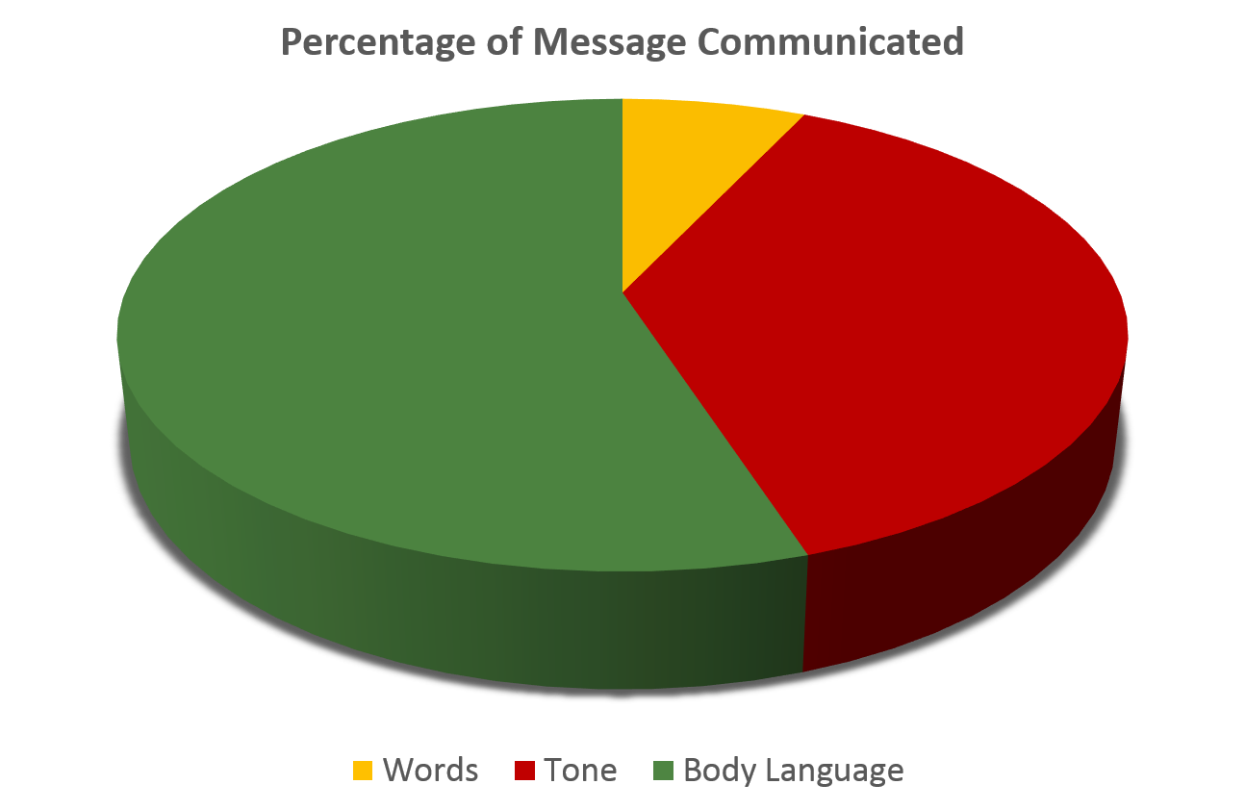

Research tells us that people communicate only seven percent of their message through word choice. Thirty-eight percent is delivered through their tone of voice, including pitch and volume, and a whopping 55 percent of the message is conveyed through body language or nonverbal cues. Most people express themselves honestly through body language without even thinking about it.

**Notes:**

#### Challenges of Nonverbal Communication

Interpreting verbal and nonverbal signals may be challenging at times because as many as ten thousand nonverbal cues may be displayed in a minute of interaction.

Focusing on one gesture may be misleading.

* A single gesture could mean any number of things, or possibly even nothing at all.
* Therefore, it’s best to read nonverbal signals as a group to see if a set of signals are positive or negative.
* If you place too much emphasis on just one signal out of many, you might reach an erroneous conclusion about what a person is trying to communicate.

For example, in Western culture, a firm handshake is often interpreted as a sign of a strong personality and a weak handshake as a lack of confidence. Depending on the individual, however, a weak handshake could indicate something else entirely, such as an injury or arthritis. A person's overall demeanor is far more telling than a single gesture viewed in isolation.

If nonverbal and verbal sets of communication contradict, you should usually trust the nonverbal signals over the verbal ones. In general, people are much less skilled at masking their nonverbal communication.

Keep in mind that stress can impact both the nonverbal signals displayed as well as how accurately those signals are interpreted. If you are in a high-stress negotiation, for example, it’s best to confirm your interpretation before acting on it.

In general, however, trust your instincts when it comes to reading nonverbal signals.

**Notes:**

#### Activity: Identifying Nonverbal Signals

What are some examples of the following types of nonverbal signals?



_______________________________________________________________________________________________________________________________________________________________________________________________________________________________________________________________

Customer is ready

to buy



_______________________________________________________________________________________________________________________________________________________________________________________________________________________________________________________________

Customer is interested but unsure



_______________________________________________________________________________________________________________________________________________________________________________________________________________________________________________________________

Customer is not interested

#### Interpreting Verbal & Nonverbal Signals

When working with a customer, what actions should you take when you hear and see the positive and negative verbal and nonverbal signals? Use this chart to help you decide.

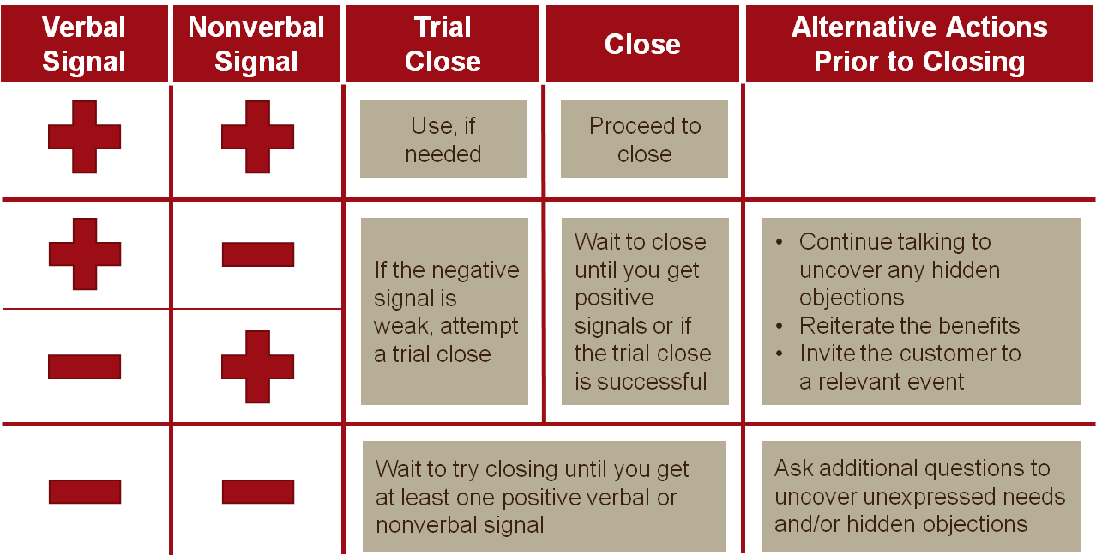

**Notes:**

#### Closing Scenarios

1. The customer is ready to buy:
   * Review benefits
   * Use positive language
2. The customer is undecided or unsure:
   * Start and end with strong value statement
   * Talk results
   * Get agreement throughout
   * Trial close
3. The customer needs more information or proof:
   * Use testimonials
   * Refer to selling aids
   * Leave information

**Notes:**

#### Activity: Determining When and How to Close

Instructions: Choose the best course of action for each of the following scenarios.

|  |
| --- |
| **Scenario 1**  You’re visiting Tony Newman, owner of a beef feedlot operation, and you’ve been discussing his silage inoculants. He’s leaning toward you, and he gestures with his hands as he talks. He has asked several questions about Biotal Plus II Silage Inoculant:   * So if we go with Biotal Plus II Silage Inoculant, the silage quality will improve… and it’ll also increase my bottom line with better performance and by having a more consistent silage? * How does the cost compare with the competition? * If we try it out, what kind of results can I expect? |
|  |
| **Scenario 2**  You’re with a long time customer, dairy nutritionist David Schwartz. David is very detail oriented and focuses on data, and he’s very change averse. He tends to review products once, make a decision, and close the door to all other discussions about technology. Now that you’ve finally gotten your foot in the door to talk with him about Levucell SC, you’re emphasizing all the trials and data that Lallemand has to offer. David is leaning back in his chair, picking the front of his feet up off the ground. He looks like he’s thinking as he asks you a few questions:   * How does the increase in pH compare to what we get with your competitor? * How much improvement do most users see in milk production? * What were those numbers you mentioned about fat corrected milk again? |
|  |
| **Scenario 3**  You’re meeting with Don Coburn of Little Pig, a swine producer. You’ve been telling him about the benefits of Agrimos, and throughout the conversation he has been smiling, nodding, looking thoughtful, and leaning toward you. When you mention the results he could expect from the product, he crosses his arms and says:   * I’m just not sure it’s worth the cost. My pigs are doing just fine with what we’re giving them now. |
|  |

### Module 4: Following Up After the Sale

#### Purpose of Post-call Follow-up

There are three main reasons that you should follow-up with your customers.

1. Measure and analyze the overall sales call effectiveness and develop an objective for  
   the next call.
2. Prioritize, document, and monitor follow-up action items and timelines.
3. Communicate the outcome and next steps with the sales and technical team.

An effective post-call follow-up communicates your commitment to building a true partnership with the customers. It shows that you value their business.

**Notes:**

#### Selling as a Cycle

Selling is not a linear process, though it may seem like one. Instead, think of it as a cycle. First, you go through your STEPs:

* Search for needs
* Talk about alternatives
* Evaluate solutions
* Present the benefit summary

Next, you close the sale. This is where many people think the sales process ends, but if this is where you stop, you risk damaging your relationship with the customers and you give up great opportunities to expand your business with them.

The remaining stages of the selling cycle are follow-up.

1. Ensure positive experiences
2. Build the relationship
3. Expand the partnership

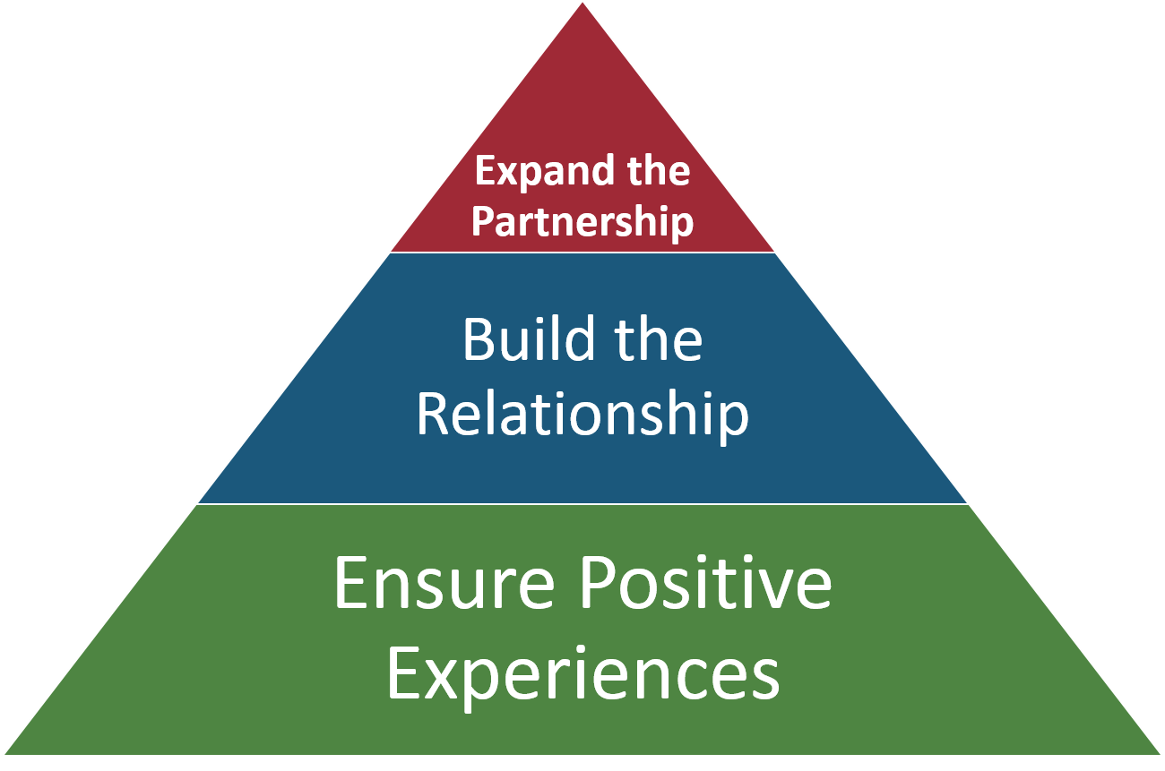

#### Stage One: Ensure Positive Experiences

******Continue your professional approach by taking customers through the next steps. Confirm what has been agreed, including delivery dates and times as well as payment procedures, where appropriate. If necessary, write down a schedule of the next steps for them, as well as clear contact details in case they have any queries during the process.

It is preferable to give clients your cell phone number to avoid a long delay in answering any query they may have. Sometimes clients may suffer "buyer's remorse" - a negative response to making a big decision - and failing to answer a query quickly and efficiently could lead them to cancel the whole order.

Once back at the office, confirm all the details in an email or letter. Avoid using standard templates for this communication - you need to maintain the friendly rapport generated in the meeting, and a standardized letter could appear too clinical. You may also want to create a schedule for regular follow-up calls at key stages to keep up on their progress.

Check that customers have received exactly what was agreed upon and that delivery was on time. Be on hand to answer any queries once the client starts to use the product, perhaps offering to demonstrate it at their workplace.

**Notes:**

#### Stage Two: Building the Relationship

Checking in with customers on their initial satisfaction simply isn’t enough. It’s important that you help customers maximize their success, because success for your customers means shared success for you!

* Building relationships takes time and is based on trust.
* You don’t want the focus of your follow-up calls to start with expanding your business with your customers. This can leave them feeling like you only care about their money, not about their business.
* If you have action items for your next call, try to give your customers action items as well. This gets them more engaged in the call and invested in your relationship.
* Always follow through with any action items.

**Notes:**

#### Stage Three: Expanding the Partnership

Once you’ve built up relationships with customers and you’ve ensured that they’re happy with the Lallemand product(s) they’re using, it’s time to think about other Lallemand products that would help their business.

It’s important that you continually reaffirm the value that we bring and ensure positive experiences with all of our products so that we keep them as customers and can expand our partnerships with them.

Don’t pigeon hole your customers. If they consistently rely on us for one aspect of their business but turn to our competitors for others, we should be able to capitalize on the success we’ve had and take that business away from our competitor.

For example, if customers rely on us for probiotics for their cattle but continue to purchase swine probiotics from a competitor, you already have your foot in the door to talk about swine probiotics with those customers. It’s convenient for them to do all of their business with the same company, and we have a track record of success with them.

**Notes:**

#### Activity: Creating a Follow-up Plan

Create a follow-up plan for each scenario. Remember to complete all three stages of follow up:

* 1. Ensure positive experiences
  2. Build the relationship
  3. Expand the partnership

|  |
| --- |
| **Scenario 1**  You’ve recently sold to a Beef Feedlot operator who had been using competitive silage inoculants because they were the least expensive on the market. He was hesitant to switch to a more expensive product, but eventually decided to give Biotal Plug II Silage Inoculants a try. He’s made it very clear that it’s important to see a return on this investment. |
|  |
| **Scenario 2**  A swine producer recently purchased Levucell SB. He was recently promoted and looking to make his mark on the company, and he thinks that Levucell SB will be a step in the right direction. He’s excited at the prospect of using less antibiotics while keeping his herd healthy. |
|  |
| **Scenario 3**  You closed a deal a few months ago at Camden Feeds, a nutrition company. Camden Feeds manufactures a complete line of nutritional products for all species – general livestock, dairy, poultry, pets or equine – from supplements to complete feeds, pelleted or textured, bagged, bulk or tote. The company is a long time forage inoculants customer, has been a dairy customer for a long time, and is now growing in the swine and poultry segments. Your most recent deal was for Agrimos, their first poultry purchase. |
|  |